Project Coversheet
Full Name | Augustine Cudjoe
Project Title (Example – Week1, Week2, Week3, Week 4) | Customer Sign-Up Behaviour & Data Quality Audit  Week1
Instructions:
Students must download this cover sheet, use it as the first page of their project, and then save the entire document as a PDF before submission.
Project Guidelines and Rules
1. Formatting and Submission
- Format: Use a readable font (e.g., Arial/Times New Roman), size 12, 1.5 line spacing.
- Title: Include Week and Title (Example - Week 1: Travel Ease Case Study.)
- File Format: Submit as PDF or Word file
- Page Limit: 4–5 pages, including the title and references.
2. Answer Requirements
- Word Count: Each answer should be within 100–150 words; Maximum 800–1,200 words.
- Clarity: Write concise, structured answers with key points.
- Tone: Use formal, professional language.
3. Content Rules
- Answer all questions thoroughly, referencing case study concepts.
- Use examples where possible (e.g., risk assessment techniques).
- Break complex answers into bullet points or lists.
4. Plagiarism Policy
- Submit original work; no copy-pasting.
- Cite external material in a consistent format (e.g., APA, MLA).
: Clear grasp of business analysis principles.
- Application: Effective use of concepts like cost-benefit analysis and Agile/Waterfall.
- Clarity: Logical, well-structured responses.
- Creativity: Innovative problem-solving and examples.
- Completeness: Answer all questions within the word limit.
6. Deadlines and Late Submissions
- Deadline: Submit on time; trainees who fail to submit the project will miss the “Certificate of Excellence”
7. Additional Resources
- Refer to lecture notes and recommended readings.
- Contact the instructor or peers for clarifications before the deadline.
YOU CAN START YOUR PROJECT FROM HERE

Week 1 Project

Customer Sign-Up Behaviour & Data Quality Audit

Rapid Scale — Business Intelligence Team
Dataset: customer_signups.csv | support_tickets.csv Period: January 2024 – October 2024 | n = 300 records

300  total records | 9.7%  early support rate | Premium  top plan | YouTube  top source (last month) | 10.0%  missing region

SECTION 1
This report presents a comprehensive data quality audit and analysis of customer sign-up behaviour for Rapid Scale, a fast-growing SaaS company offering three subscription plans: Basic, Pro, and Premium. The analysis is based on the customer_signups.csv dataset, which contains 300 customer records, alongside an optional support_tickets.csv dataset used to assess early customer support interactions.The purpose of this report is to support the Monthly Business Review (MBR) by identifying data quality issues, analysing user acquisition trends, and providing actionable insights to improve marketing performance and onboarding processes. The findings aim to assist non-technical stakeholders in making informed business decisions.

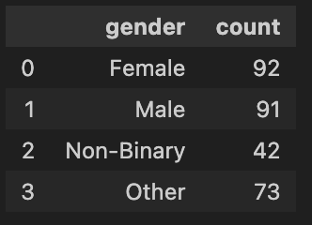

3.4 Age summary: min, max, mean, median, null count
The age distribution of users ranges from 21 to 60 years, with a mean age of 35 and a median of 34, indicating a fairly balanced spread.The relatively small difference between the mean and median suggests that the data is evenly distributed with minimal skewness, making it suitable for generalised insights and decision-making.

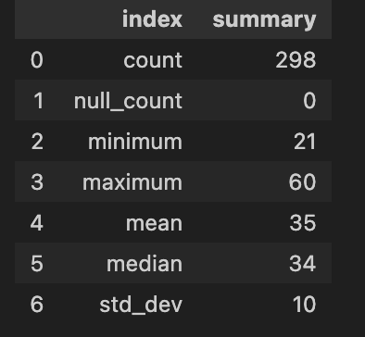

SECTION 4

Business Question Answers
Q1 Which acquisition source brought in the most users last month?
Google was the leading acquisition source in the most recent month, generating the highest number of sign-ups (3). Instagram and Unknown sources followed with 2 sign-ups each. The presence of “Unknown” (representing missing or NaN values) indicates gaps in tracking, suggesting that some acquisition channels were not properly recorded.

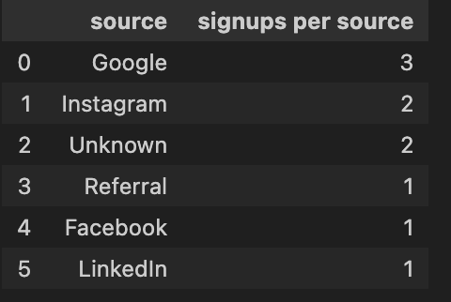

Q2 — Which region shows signs of missing or incomplete data?
The North region shows the highest level of missing or incomplete data, with multiple gaps across key fields such as email, age, and plan selection. In addition, a portion of the dataset has no region recorded at all, suggesting potential issues with data entry or system integration.

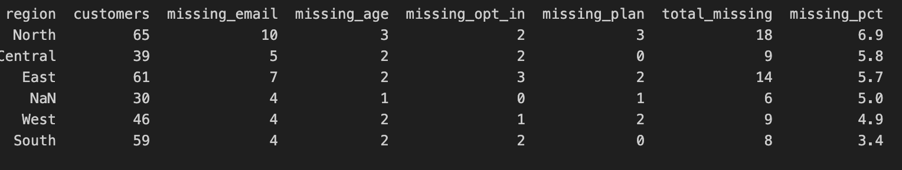

Q3 — Are older users more or less likely to opt in to marketing?
Older users are slightly more likely to opt in to marketing communications; however, the relationship is weak. Differences across age groups are minimal, indicating that age is not a strong predictor of marketing opt-in behaviour.

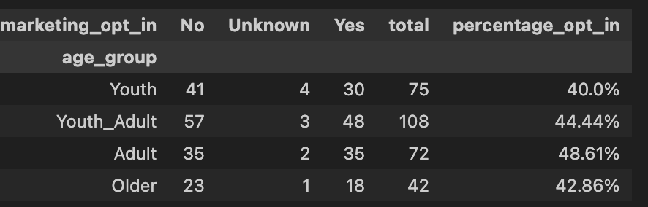

Q4 — Which plan is most commonly selected, and by which age group?
The Premium and Pro plan are the most commonly selected overall, particularly among Youth_Adult. This group represents the most active segment and shows a stronger preference for higher-tier subscription options.

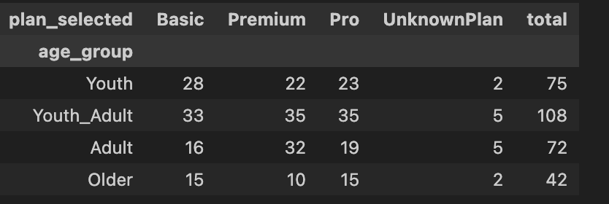

Q5 (Optional) — Which plan's users are most likely to contact support?
Users on the Pro plan are the most likely to contact support, followed by Basic users. Premium users have the lowest support interaction rate, suggesting a smoother user experience for higher-tier customers.

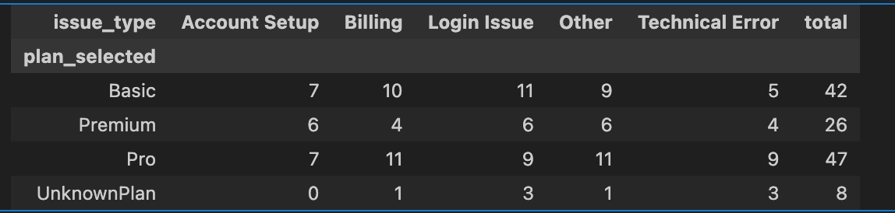

OPTIONAL STRETCH TASK — SUPPORT TICKET ANALYSIS
Q1.Count how many customers contacted support within 2 weeks of sign-up
A total of 47 customers contacted support within two weeks of signing up.
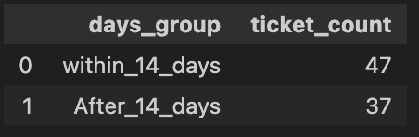

Q2. Summarise support activity by plan and region (Group by plan and region)
Support activity is highest among Pro plan users and varies across regions, with some regions recording more support interactions than others.

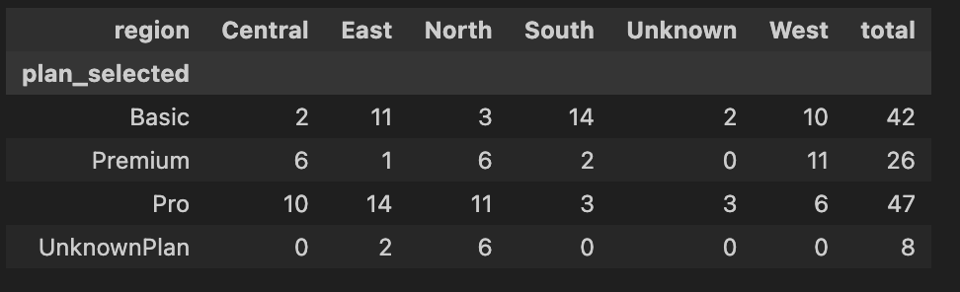
SECTION 5: Recommendations
- Prioritise high-performing acquisition channels: Since Google and Instagram generated the most recent sign-ups, marketing efforts should focus more on these platforms to improve customer acquisition.
- Improve data tracking and attribution: The presence of “Unknown” sources indicates missing data. Implementing proper tracking mechanisms (e.g., mandatory UTM parameters) will ensure more accurate reporting of acquisition channels.
- Enhance onboarding for Pro and Basic users: As these users are more likely to contact support, improving onboarding guidance and user support resources can reduce early-stage challenges and improve user experience.

SECTION 6: Data Issues or Risks
- Data Quality Issue: A key issue identified is the presence of missing or unrecorded acquisition sources, represented as “Unknown” (NaN values), which limits accurate analysis of marketing performance.
- Proposed Solution: This can be addressed by enforcing stricter data entry validation and implementing mandatory tracking parameters at the point of data collection, ensuring all acquisition sources are properly captured in future reporting.

